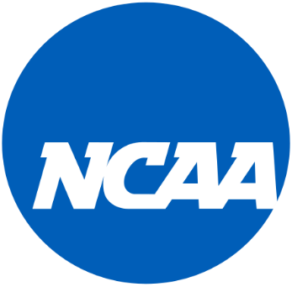
NCAA NIL Policy Brief:
The Breakdown of New Monetary Opportunities for College Athletes
By: Lachlan Sawall

Executive Summary
The NCAA has been at odds with athletes and collegiate institutions all over the United States over the “Name, Image and Likeness” restriction for 65 years. The NCAA rule prohibited college athletes from making money off their name, image, and fame or from endorsements because the NCAA believed it interfered with the concept of ‘amateurism’. However, this policy (NIL) recently changed on July 1, 2021, allowing college athletes to make money off their name, image, likeness, and fame. In other words, collegiate student-athletes now have the possibility of paid compensation by promoting, partnering, or representing brands or businesses.
While the NIL rule change is a big win for college athletics, it has also led to a ‘wild-west’ type policy making structure in each state and NCAA universities as they try to navigate the new landscape that is NIL with hardly any guidelines to follow. In order, to better understand the policy making structure of the new NIL policy, I have broken down several state NIL policies and categorized them based on their focus and structure in order to better understand the positive and negative externalities of each state policy as well as locating future implications if left unchecked.

What’s the Problem?
The main problem is that the NCAA and the supreme court dropped a bombshell on state governments as well as NCAA universities by overturning the amateurism rule which has led to a patchwork of different state policies based on their legal structure and reactionary values regarding NIL. Furthermore, many of these policies were thrown together in order to just get something out there and weren’t done focusing on the implications that these types of policies can create. On top of that, because each state and many colleges have different policies regarding NIL, it has made the recruiting process that much more complicated. Athletes and coaches now must focus on what each state policy and college have to offer regarding their NIL policy on top of the potential NIL deals they can obtain there. As one can imagine, this type of patchwork policymaking can lead to a ton of implications and loopholes regarding NIL down the road which could end up hurting colleges, student athletes, state governments, businesses, and fans alike. Some of the more prominent implications that experts are worried about are as follows:

- Will student athletes will simply put off school or do the bare minimum in order to focus on endorsement money and their sport?
- What happens if a student athlete gets into a bad contract because they sign the dotted line when they see the money?
- Speculation that schools in states that aren’t as prominent for major sports teams such as Wyoming, South Dakota, etc could lose potential star athletes for their teams.
- Will the 4 major sports of hockey, football, baseball, and basketball make the most money because they are in the media spotlight? What does this mean for the other sports?
- Are the rule changes going to have the same effect in every state or are some states going to pull ahead in monetary gain?
There are also many other implications that need to be addressed in order to make sure that the implications of the new NIL policy do not outweigh the positives. However, at this point in time, because the policy change is brand new, there is not enough information or studies done on how everyone is affected now or how it will affect the future. Although, this goes to show why this policy is so important. The NIL policy is perhaps the biggest change to sports law ever. This is the first time that college athletes will be allowed to make money off of the image that they want to display around the country, and it also is a huge opportunity to have a positive influence on the states and communities around the country as well. That is why it is important to make sure that the implications of the NIL deal will not outweigh the benefits in order for this policy to flourish. However, in order to do that, the first thing that needs to be understood are the types of policies that states are creating and make them easier to understand in order to break down potential future problems and create solutions before they arise.

Analysis

At the present moment, with some many new NIL policies being created around the country, most people do not really know what is happening, what type of NIL policies are the best and what the implications these NIL policies can have in the future. So, in order to better understand the policy layout of NIL, I read over numerous different state policies that have been implemented and categorized them based on their focus and structure to better understand the positive and negative externalities of each state policy as well as locating future implications if left unchecked. As shown in the table below, the three major themes I continuously wound were that the state policies were centered around either Old School Amateurism, Athletes, or Colleges.

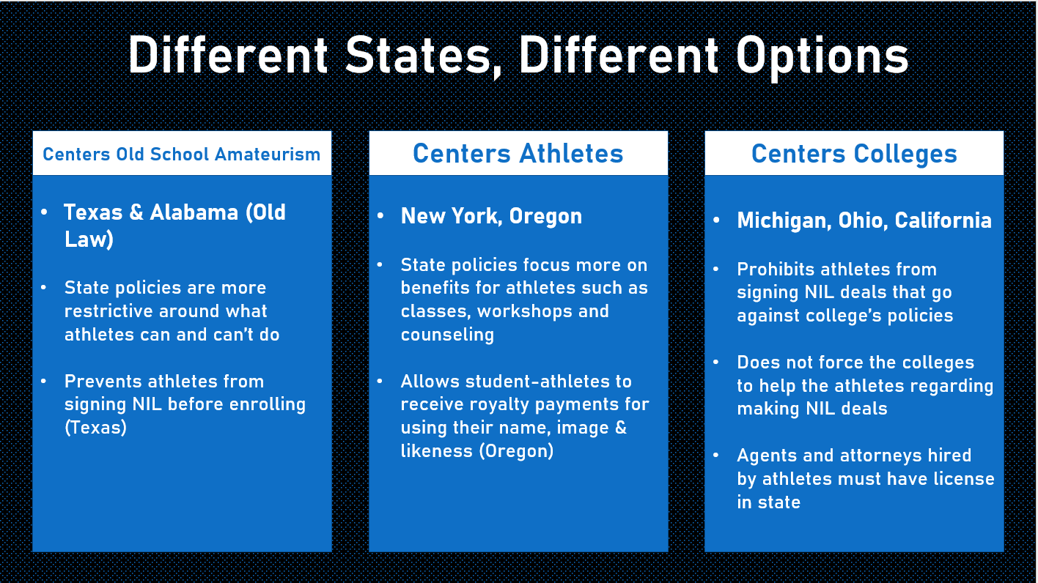

Centers Old School Amateurism
As the title implies, the Old School Amateurism policies are set up in a way that are more restrictive than others. This means that the state policies focus more on what student, college and businesses can and can’t do regarding NIL. For example, Texas and Alabama both have similar stipulations in their NIL policy that restricts athletes from signing deals and earning compensation for: athletic performance or attendance at institution, property from institution or endorsement using intellectual property, or endorsements on alcohol, tobacco products, e-cigarettes or any other type of nicotine delivery device, anabolic steroids, sports betting, casino gambling, a firearm the student athlete cannot legally purchase, or a sexually oriented business. Additionally, student athlete’s contracted NIL deals cannot extend beyond the student athletes’ participation in the intercollegiate athletic program. Finally, there are even some restrictions that are put in place in order to minimize damage to their state’s image. For example, Texas NIL law has a stipulation that states that no potential athletes, corporate entity, or other organization may enter into any arrangement with a prospective student athlete relating to their NIL prior to their enrollment in an educational institution. As one can see, the NIL laws and stipulations from states that fall into the ‘Old School Amateurism’ category are more restrictive and lay out the groundwork for what student athletes and colleges can and can’t do regarding NIL.
Centers Athletes
State policies that fall into this category are set up in a way in which the NIL laws and stipulations revolve more around the benefits of student athletes and what they can do to help them. An example of this can be from creating multiple types of workshops, classes, and different forms of counseling. In this case, the state of New York leads by example by making each college athletic program that participates in Division 1 NCAA athletics offer a student-athlete assistance program or programs, designed to provide student-athletes, participating in Division 1 sports, with important tools aimed to enhance their well-being and experiences in the classroom, off the field of play, and beyond their tenure as student-athletes. Aside from states policies strictly focusing on student athlete benefits related to classes, workshops or counselling, there are some states such as Oregon that have created stipulations that focus on NIL benefits related to royalties and protecting athletes against sport agents. Oregon’s law states: A person that produces an intercollegiate sports team jersey, video game or trading card for the purpose of making a profit shall make a royalty payment to each student athlete for use of the student athlete’s name, image or likeness if the person uses the student athlete’s name, image or likeness in or on the intercollegiate sports team jersey, video game or trading card. This shows that there are some states that are focused more on trying to increase the benefits that athletes have through NIL which also will play a massive part in trying to recruit potential athletes to the colleges in their state.
Centers Colleges
State policies that fall under this category tend to, as the name implies, center around colleges. States that fit into this category are states such as Michigan and Ohio. These state policies are more relaxed and basically lean on the colleges to come up with NIL policies based upon what they deem to be the most beneficial for the student athletes and the NIL landscape that surrounds them. Furthermore, many of these state policies specifically say that colleges are not required to help the athletes in any way regarding NIL deal/opportunities for students. This was more or less put into place because firstly, colleges cannot pay student athletes or on a firsthand basis get involved with their NIL deals besides telling athletes if their deal is infringing upon the colleges policies. Secondly, many of the athletes want to be treated as professionals and not having their hand held while creating their own image regarding the deals that they sign, meaning that colleges are not strictly forced to help the student athletes regarding their deals in any ways, even though most colleges in these states have already set up some type of system to help. This state policies that fit into this group are most likely labeled as ‘least restrictive’ because the actual state policies do not have too many restrictions as opposed to the other groupings.
It is clear that each state law regarding NIL is created based upon the political and legal structure of each state, as well as the values that each state holds when they are creating their NIL policy. Furthermore, the state NIL laws also show that the states are also competing in a way by deciding what they put in their NIL laws, so they have a better chance of enticing potential recruits to come to their state colleges because the laws are more beneficial. Although, at the present moment there is not enough tangible information regarding how each state law is affecting where each athlete is going to school or transferring because the new NIL policy has been around for less than a year. The same goes for the implications of these new state policies, myself as well as many other expert in NIL are still waiting to see how the landscape of NIL is going to change after its first complete athletic season and see if any states try to make amendments based upon the ever changing landscape of the NIL.
Recommendations
Mandatory Class Over NIL Rules and Contracts
Based on my research on NIL it is clear that there isn’t too much information to go on regarding present implications that are happening now and where the NIL policy landscape is going in the future. However, with student athletes now being able to sign contracts and deals with brands and businesses, it is imperative that these student athletes, especially the ones just coming out of high school, know what they are doing when making deals and what is happening in the NIL landscape if it continues to be a patchwork of state and collegiate legislation. As a 17–18 year old coming into college, most of them have no idea how to negotiate a contract with a business, how to deal with agents, what to do when they receive an income or even what signing an NIL deal signifies. Every school that is part of NCAA athletics should have to create a mandatory class that all student athletes have to take during their freshman year and other years if deemed necessary. These classes should focus on many different aspects that college athletes are now involved in such as contracts, communication, leadership, financial literacy, how to deal with an agent/business, the NIL landscape and the ins and outs of the state/college policy at the university. This would help student athletes across the United States be better prepared when making and finding NIL deals as well as preparing them for their future jobs / professional athletic careers.
Federal NIL Policy
If there was only one thing that could be done regarding NIL, it should be a federal NIL policy. The reason for this is because a federal policy would put states, colleges, athletes, and businesses/brands all on the same page regarding NIL. This would mean that colleges and potential athletes don’t have to worry about the different state policies as well as the college policies regarding NIL when trying to choose a college that they want to play their sport at. The federal policy does not even have to be that extensive and could just lay a basic groundwork for the do’s and don’ts of NIL policy and allow either the colleges or the states to determine small other stipulations that could make them “unique” from the other NIL policies but would still be relatively the same. Overall, a federal NIL policy would limit the amount of confusion that is prevalent in the NIL landscape as well as set a basis in which it is easier to learn about certain implications and loopholes that can arise from this policy and make amendments to it as necessary because each state and college will be on the same page.

References

Bynum, Caroline. “What Is NIL? Everything to Know about the NCAA Rule Allowing College Athletes to Get Paid.” On3. On3.com, 14 Aug. 2021. Web. 14 Oct. 2021. https://www.on3.com/news/what-is-nil-everything-to-know-about-ncaa-rule-allowing-college-athletes-paid/
“Texas Nil Law for NCAA.” Spry, Spry, 31 Jan. 2022. Web. 04 Mar. 2022. https://spry.so/nil-state-guide/texas-nil-law-for-ncaa/
“Texas Nil Law for NCAA.” Spry, Spry, 31 Jan. 2022. Web. 04 Mar. 2022. https://spry.so/nil-state-guide/texas-nil-law-for-ncaa/
“New York Nil Law for NCAA.” Spry, Spry, 31 Jan. 2022. Web. 04 Mar. 2022. https://spry.so/nil-state-guide/new-york-nil-law-for-ncaa/
“Oregon Nil Law for NCAA.” Spry, Spry, 31 Jan. 2022. Web. 04 Mar. 2022. https://spry.so/nil-state-guide/oregon-nil-law-for-ncaa/
“Ohio Nil Law for NCAA.” Spry, Spry, 31 Jan. 2022. Web. 04 Feb. 2022. https://spry.so/nil-state-guide/ohio-nil-law-for-ncaa/
“Michigan Nil Law for NCAA.” Spry, Spry, 31 Jan. 2022. Web. 04 Feb. 2022. https://spry.so/nil-state-guide/michigan-nil-law-for-ncaa/.

